**DAILY ONLINE ACTIVITIES SUMMARY**

|  |  |  |  |  |  |  |  |
| --- | --- | --- | --- | --- | --- | --- | --- |
| **Date:** | **21/06/2020** | | | | **Name:** | **Syed Rabeya Aamir** | |
| **Sem & Sec** | **8th B** | | | | **USN:** | **4AL16CS112** | |
| Online Test Summary | | | | | | | |
| **Subject** | | **--** | | | | | |
| **Max. Marks** | | **--** | | **Score** | | **---** | |
| Certification Course Summary | | | | | | | |
| **Course** | **Amazon DynamoDB for Serverless Architectures.** | | | | | | |
| **Certificate Provider** | | | **Aws** | **Duration** | | | **2 hrs** |
| Coding Challenges | | | | | | | |
| **Problem Statement:**  **1)** Python code to find sum of elements in given array. | | | | | | | |
| **Status: Solved** | | | | | | | |
| **Uploaded the report in Github** | | | | **YES** | | | |
| **If yes Repository name** | | | | **rabeya** | | | |
| **Uploaded the report in slack** | | | | **YES** | | | |

**Certification Course Details:**

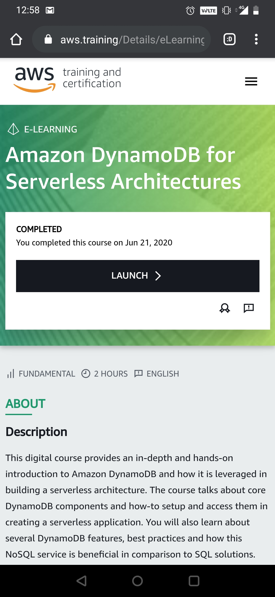

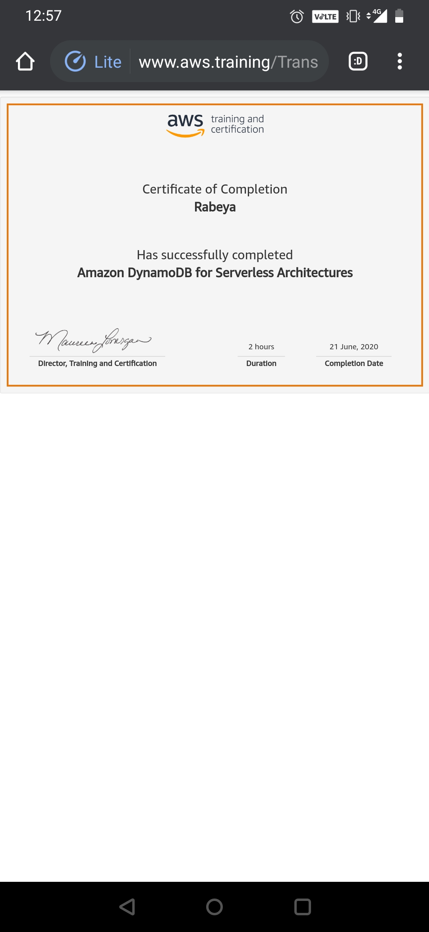

# CODE:

Program no:1

# Python code to find sum of elements in given array.

def _sum(arr,n):

# return sum using sum

# inbuilt sum() function

return(sum(arr))

# driver function

arr=[]

# input values to list

arr = [12, 3, 4, 15]

# calculating length of array

n = len(arr)

ans = _sum(arr,n)

# display sum

print ('Sum of the array is ', ans)